**Press release***Trade press*

**Jorge Cuevas Martín appointed head of Global Service**

**As part of strategic reorganization, Kautex Maschinenbau has made a further appointment to an executive position: Since May 2020, Jorge Cuevas Martín is head of the company’s service provision as Global Service Manager. He will be responsible for the areas of After Sales and Parts Service. The 51-year-old Spaniard was originally an energy and air-conditioning technician and has worked for a range of international companies. Before joining Kautex, he was CEO of a Spanish subsidiary of a German heat exchanger company.**

Jorge Cuevas will be responsible for the key interface to the customer. He is due to coordinate and ensure customer-focused expansion of the company’s comprehensive service provision worldwide. In addition to the coordination of the decentralized service teams and parts centers, it also includes further expansion of the service and parts provision using digital technology such as remote services, digital spare parts ordering and remote servicing.   
  
CSO Andreas Lichtenauer is looking forward to working with his new colleague: “Customer focus and service play a key role in our process of change. Our aim is to achieve even greater decentralization of our global service provision and continue to consolidate our high standards. Jorge Cuevas brings the experience and seniority needed to accelerate this process and develop even closer customer focus.”

Kautex Maschinenbau is a global leader in the supply of extrusion blow molding machines. The company HQ and central product development is in Bonn, subsidiaries and branches in China, USA, Italy, Russia, India, Mexico and Malaysia. An international team of trained service technicians advise and support customers worldwide without any language and technical barriers. The decentralized warehousing of parts and accessories enable fast response times and short delivery channels.

Cuevas: “The plastics market is constantly developing, and requirements change quickly. Our job is to offer our customers the best possible support for adapting their production to the current market conditions. Customer service is a crucial factor here. I’m looking forward to be able to drive forward this mission as part of the global Kautex team together with our customers and partners.”

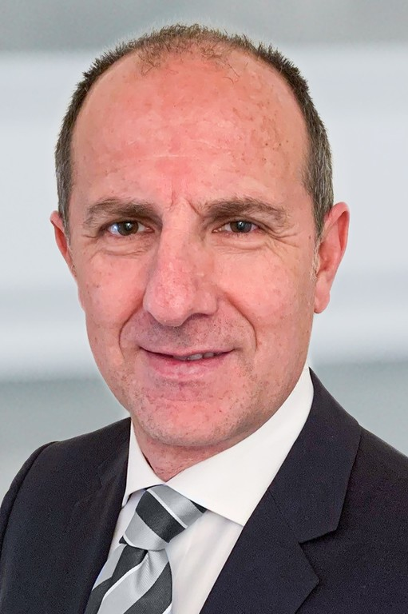 **Jorge Cuevas Martín**

**About Kautex Maschinenbau**Eight decades of providing its customers with innovative products and services have turnedKautex Maschinenbau into one of the world's leading companies in extrusion blow molding technology. With customers that include major automobile manufacturers and suppliers, as well as companies working in the packaging industry. All of them have come to rely on the knowledge and experience of a brand that stands for both quality and reliability. In addition to its HQ in Bonn, a Customer Service Center in Berlin and regional offices in the USA, Russia, China, Italy, India, Mexico and Malaysia, Kautex Maschinenbau operates an extensive global network of service and distribution offices. **Contact details**

**Christian Kirchbaumer**  
Head of Marketing Communications

**Kautex Maschinenbau GmbH**  
Kautexstr. 54  
53229 Bonn  
Germany

T +49 228 489370

christian.kirchbaumer@kautex-group.com